**OBJECT ORIENTED SOFTWARE ENGINEERING LAB FILE**



SUBMITTED TO – MS RUCHIKA MALHOTRA

NAME – NAVENDU GUPTA

ROLL NUMBER-2K15/SE/041

DELHI TECHNOLOGICAL UNIVERSITY

DEPARTMENT – COE

BRANCH – SOFTWARE ENGINEERING

**INDEX**

|  |  |  |  |
| --- | --- | --- | --- |
| **S.NO.** | **TITLE** | **DATE** | **SIGNATURE** |
|  |  |  |  |
|  |  |  |  |
|  |  |  |  |
|  |  |  |  |
|  |  |  |  |
|  |  |  |  |
|  |  |  |  |
|  |  |  |  |
|  |  |  |  |
|  |  |  |  |

**EXPERIMENT-1**

**AIM:** Write a problem statement for COURSE MANAGEMENT SYSTEM.

**THEORY**:

A problem statement is a clear concise description of the issues that needs to be addressed by a problem solving team. It is used to centre and focus the team at beginning, keep the team on track during the effort, and it is used to validate that the effort delivered an outcome that solves the problem statement.

**PROBLEM STATEMENT:**

We have to develop a COURSE MANAGEMENT APPLICATION which will be used to efficiently manage the courses opted by the student.

A user interface will be provided to the client which is required to support all the features of a standard Course Management System such as mark and print attendance, check and print report cards, upload and download the study material and assignments, online marking of grades of students by the faculty, filling of registration form by the students at the beginning of each semester, discussion of doubts.

**EXISTING SCENARIO:**

* The Faculty members mark the attendance manually**.**
* The Faculty members calculate the grades manually**.**
* There is no facility to post or discuss a doubt**.**
* The course material have to be distributed manually.
* The students are not able to view his/her attendance on regular basis.
* The students have to collect their report cards themselves from the department.
* No facility to record/view previous lectures.
* Students have to fill and submit their registration form in the department.

**FEATURES OF THE PROPOSED SYSTEM:**

* The student and faculty members should be provided by the facility to login to the system.
* The student should be provided by a list of courses in the starting of each semester from which they can choose and fill their Registration Form online.
* It should also provide the ability to student to print the registration form of the personal details and the courses opted by the student.
* The students should be able to change their phone no, Address and email id.
* The students should be provided by the facility to view his/her attendance and download the attendance as well.
* The faculty should be provided with the ability to add courses, delete courses, view attendance, mark attendance of every student, enter marks of students, print report card, upload course material, lectures and assignments.
* The students should be able to download and print their report cards.
* There should be a forum facility for discussion.

**RESULT:**

The problem statement of the system assigned is properly understood and laid out in front of the students. Also, the functionality of the system is described, which will make the further steps in project easier.

**DISCUSSION:**

The definition of the problem statement of the system has made a clear picture of the system under consideration, which will help in smooth passage into the next segments of the project.

**CONCLUSION:**

The problem statement is produced which contains all the consolidated requirements of the software to be produced.

**EXPERIMENT-2**

**AIM:** Write the initial requirement document of **COURSE MANAGEMENT SYSTEM.**

**THEORY:**

Information Requirement Document (IRD) is the most basic paperwork produced during the software development. It is written during the inception of the software development process.

The IRD is used to consolidate and compile all the initial requirements of the user/customer. The IRD also consists of other important information about the software, such as Title of Project, Stakeholders Involved, Techniques used to capture requirements, Development Team Members, and the Version of the Software being produced.

Development of IRD has many advantages, such as it specifies all the initial requirements for the software and it also acts as an input to create Use-Case Diagram, which is also an important document produced during software development.

**STEPS TO BE FOLLOWED:**

* The specified format of writing the IRD is looked up.
* The format of the IRD is written on the word file.
* The various sections of IRD are filled accordingly, such as Version, Stakeholders Involved etc.
* The requirements are consolidated and are written under the ‘Consolidated Requirements’ section.

**RESULT:**

**INITIAL REQUIREMENT DOCUMENT**

|  |  |
| --- | --- |
| **TITLE** | Course Management System |
| **STAKEHOLDERS INVOLVED** | Students, faculty members, data administrator. |
| **TECHNIQUES USED IN CAPTURING REQUIREMENTS** | Interviews, Brainstorming, Use Cases. |
| **DEVELOPERS** | Mayank Bajaj  Navendu Gupta |
| **DATE** | 24.08.2017 |
| **VERSION** | 1.0 |
| **CONSOLIDATED INITIAL REQUIREMENTS** :   * There should be login id for each student, faculty member and data administrator. * The student should be able to fill a registration form and choose courses at the beginning of the semester. * There should be a print facility for printing the registration form. * There should be a feature to update phone no, address and email id. * The students should be able to view and print their attendance. * Students should be able to download and print their report cards. * The faculty should be able to add and delete courses. * The faculty should be able to view and mark attendance of every student. * Faculty will be provided with the feature of entering marks of students, print report card, upload course material, lectures and assignments. * There should be a forum facility for discussion. | |

**DISCUSSION:**

The Initial Requirement Document of the system has made a picture of the system under consideration, which will help in smooth passage into the next segments of the project.

**CONCLUSION:**

The Initial Requirement Document is produced which contains all the consolidated requirements of the software to be produced.

**EXPERIMENT-3**

**AIM:** To make USECASE Diagram for Course Management System.

**DESCRIPTION:** The purpose of use case diagram is to capture the dynamic aspect of a system. But this definition is too generic to describe the purpose.

Use case diagrams are used to gather the requirements of a system including internal and external influences. These requirements are mostly design requirements. So when a system is analyzed to gather its functionalities use cases are prepared and actors are identified.

Now when the initial task is complete use case diagrams are modelled to present the outside view.

So in brief, the purposes of use case diagrams can be as follows:

* Used to gather requirements of a system.
* Used to get an outside view of a system.
* Identify external and internal factors influencing the system.
* Show the interacting among the requirements are actors.

Use case diagrams are considered for high level requirement analysis of a system. So when the requirements of a system are analyzed the functionalities are captured in use cases.

So we can say that use cases are nothing but the system functionalities written in an organized manner. Now the second things which are relevant to the use cases are the actors. Actors can be defined as something that interacts with the system.

The actors can be human user, some internal applications or may be some external applications. So in a brief when we are planning to draw an use case diagram we should have the following items identified.

* Functionalities to be represented as an use case
* Actors
* Relationships among the use cases and actors.

Use case diagrams are drawn to capture the functional requirements of a system.

**STEPS FOLLOWED:** The following provides an outline of processes to draw an efficient use case diagram.

* Identify all the different users of the system.
* Create a user profile for each category of users, including all the roles the users play that are relevant to the system. For each role, identify all the significant goals the users have that the system will support. A statement of the system’s value proposition is useful in identifying significant goals.
* Create a usecase for each goal, following the usecase template. Maintain the same level of abstraction throughout the usecase. Steps in higher level use cases may be treated as goals for lower level (i.e. more detailed), sub-use cases.
* Structure the use cases. Avoid over-structuring, as this can make the use cases harder to follow.
* Review and validate with users.
* Connect the users to the functionality initiated by them in the system.

**RESULTS:**

ACTORS:

* Student
* Faculty Member
* Data Entry Operator
* Administrator

USE CASES:

* Login
* Register
* Maintain Course Details
* Maintain Student Details
* Maintain Faculty Details
* View attendance
* Maintain Attendance
* Maintain Marks
* View Marks
* Post in forum
* Upload course material
* Download course material
* Print marks
* Print attendance

**USE CASE DIAGRAM FOR COURSE MANAGEMENT SYSTEM**

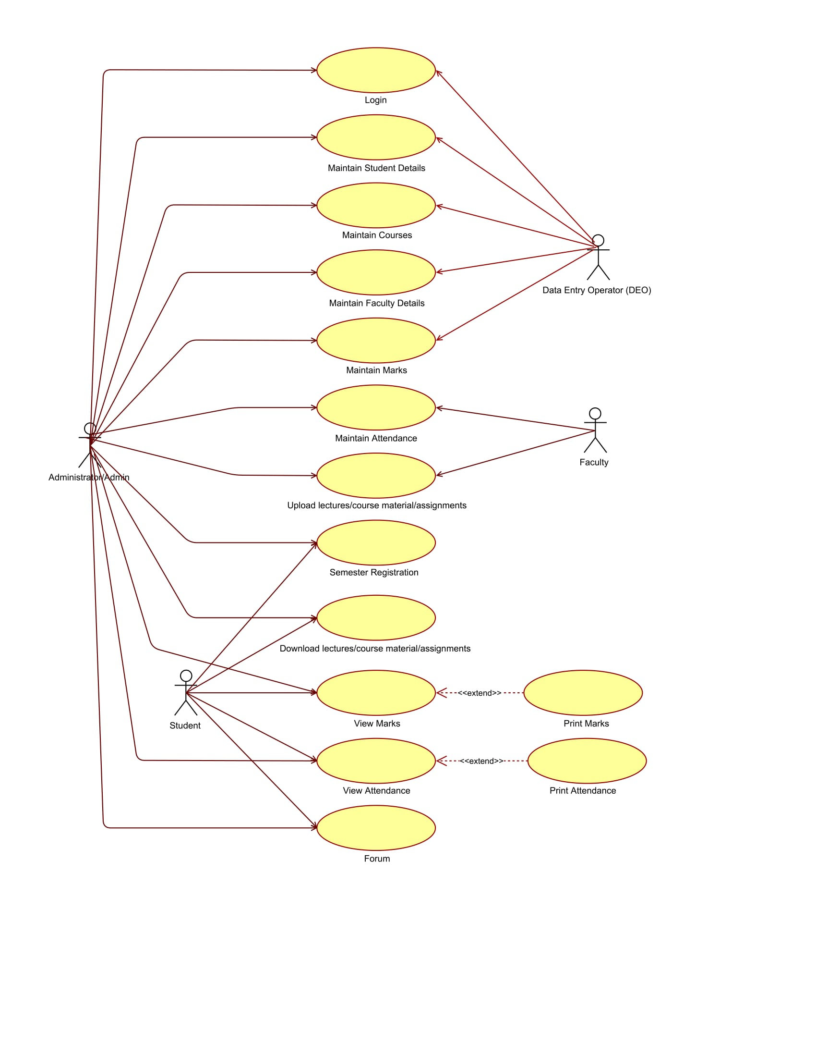

**DISCUSSIONS:** We learnt to make the USECASE diagram of the “Course Management System” case study by identifying use cases, Actors and relationships between them.

**CONCLUSION:** USECASE Diagram for course management system has been implemented.